* [**How to create a promoted links list (PART 3)**](https://sharepoint.rackspace.com/learning/articles/Pages/SharePoint-2013--how-to-create-a-promoted-links-list-app-part-3.aspx)

Here we go, Part 3!  Thanks for coming back; If you haven’t looked at Part 1 and Part 2, you may want to do so now.  We’ve already added one link to our “PromotedIcons” list but let’s add one more so you get the hang of it. Sometimes it can be trickier than you think.

1. Navigate to your Promoted Links list, in this example that is my “**PromotedIcons**” list.

2. At the top of the page click **ITEMS**, to expand the ribbon.

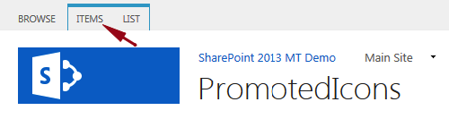

3. In the New section click **New Item**.

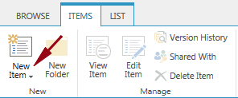

4. For this example, enter the following information below:

* 1. Title – **SharePoint 2013 Tutorials**
  2. Background Image Location – **https://scuba3.atrackspace.com/Pictures/RackspaceIcon.gif** (Image stored in SharePoint Picture Library)
  3. Description – **Link to Rackspace SharePoint Tutorials**.
  4. Link Location – **http://sharepoint.rackspace.com/2013-Articles**
  5. Launch Behavior – **In page navigation**
  6. Order – **2**

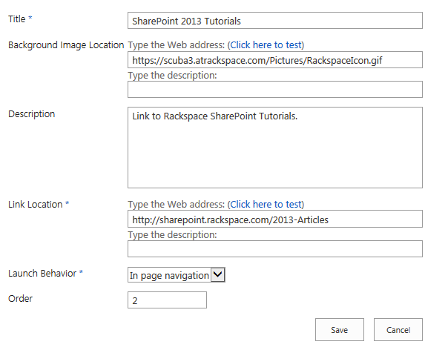

5. Review your information and click **Save**.

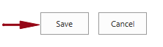

You will see your new “SharePoint 2013 Tutorials” link in the “PromotedIcons” list.

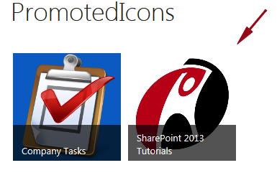

That’s not all though. If you navigate back to the SharePoint page you added the “PromotedIcons” web part to in Pa​rt 2, you will see the new icon. Go back into the “PromotedIcons” list and try to edit one of your links. Editing the links isn't quite as easy as you might hope. If you click on the one of the links you created it will take you to the link location.  Where in a normal SharePoint 2013 list it would display the items properties.  The best way to edit your links is to switch the default views from “Tiles” to “All Promoted Links.”

6. At the top of the page click **LIST**, to expand the ribbon.

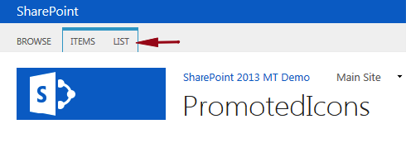

7. In the Settings section click **List Settings**.

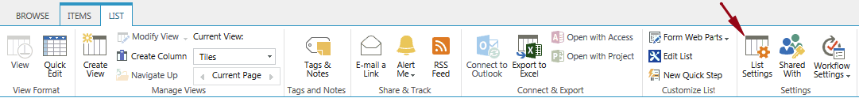

8. On the Settings page scroll to the Views section and click **All Promoted Links**.

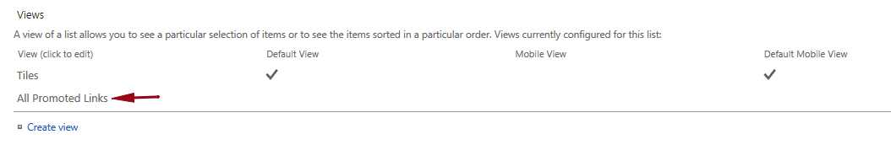

9. In the Name section check the box next to **Make this the default view (Applies to public views only).**

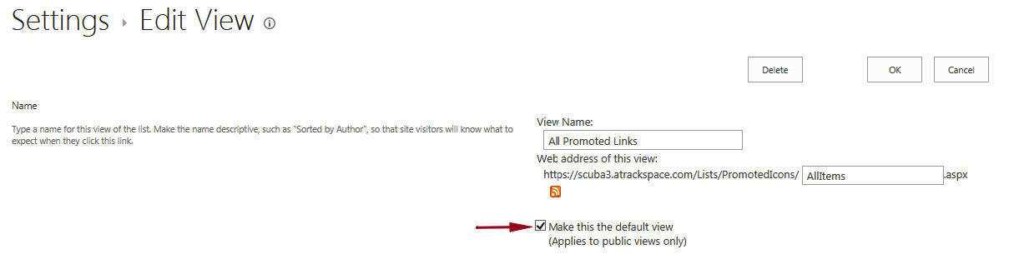

10. Click **OK**.

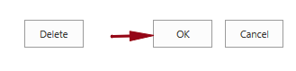

Your items will now be displayed similar to other SharePoint 2013 lists, which will make it easier to edit. Also, since we set this as the default view even if you navigate away from the page and come back this view will remain.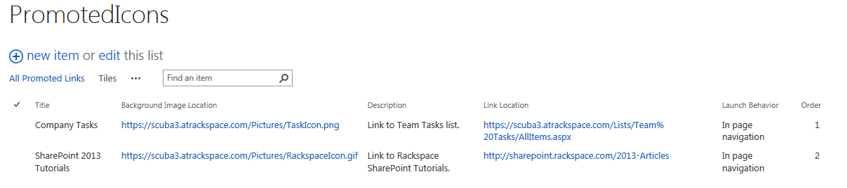

Now it’s time to impress your co-workers and show them what you learned!

​